**Сроки проведения и регистрации на итоговое сочинение (изложение). Места регистрации**

[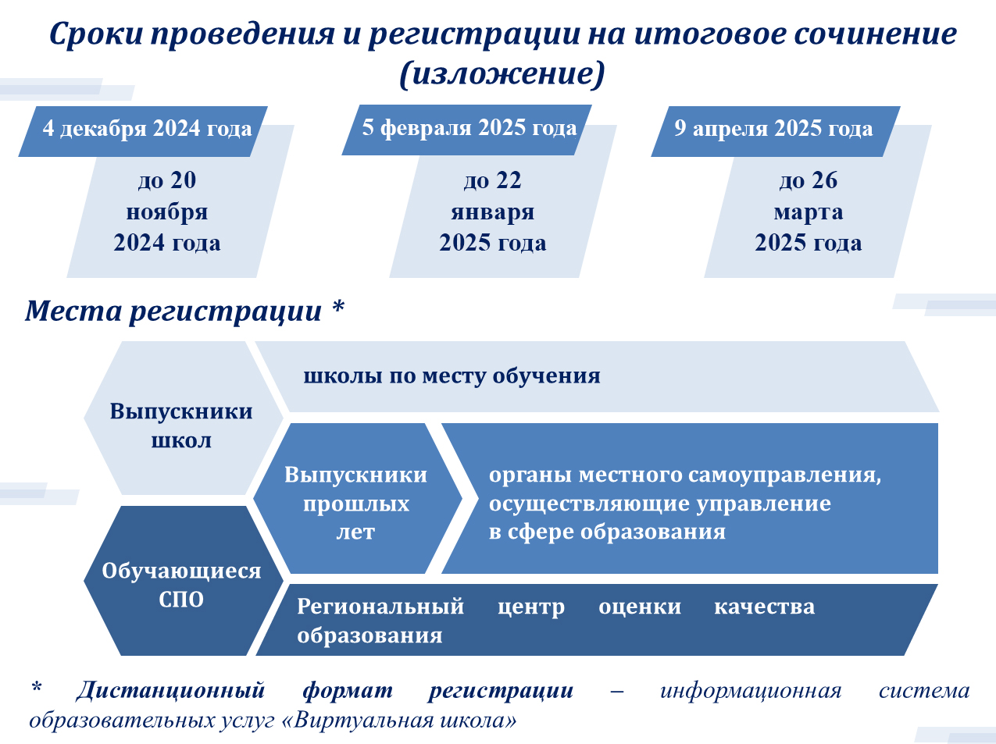](http://www.orcoko.ru/wp-content/uploads/2019/09/%D0%A1%D1%80%D0%BE%D0%BA%D0%B8-%D0%BF%D1%80%D0%BE%D0%B2%D0%B5%D0%B4%D0%B5%D0%BD%D0%B8%D1%8F-%D0%B8-%D1%80%D0%B5%D0%B3%D0%B8%D1%81%D1%82%D1%80%D0%B0%D1%86%D0%B8%D0%B8-%D0%BD%D0%B0-%D0%98%D0%A1_1.jpg)